**Results and Background Analysis**

The tunnel diode can be used to produce high-speed switching in circuits. Applications that require this functionality include devices using the ultra high frequency (UHF) bands, oscilloscopes, and other devices that require the use of a trigger with a very fast rise time.

Below is a circuit that uses a tunnel diode to rapidly switch the output voltage ($V_{out}$):

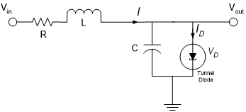

The values of the circuit components are *R* = 1.5 k $Ω$, *C* = 2 pF, *L* = 5 $μ$ H. The current through the tunnel diode is given by the equation



with $I_{D}$ in units of mA, and $V_{D}$ in units of V.

The circuit has a pulse input voltage of the following form:

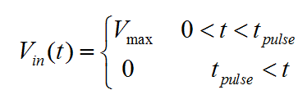

The circuit equations are:

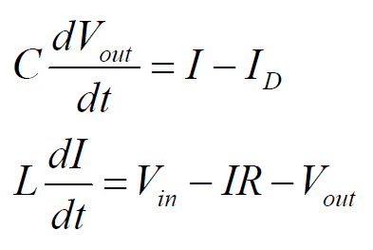

and the state variables are $x_{1}=V_{out}; x_{2}=I_{L}; u = V_{in}$.

The following is a Simulink model of the system:

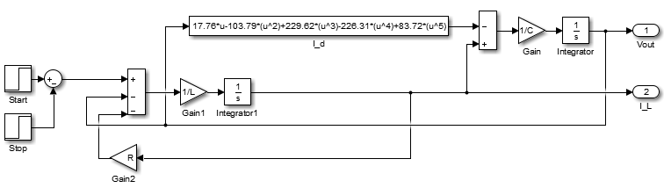

The following is a bifurcation plot of the output voltage vs. the input voltage:

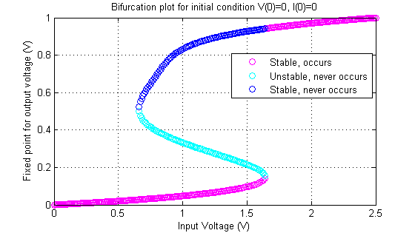

Based on the graph, for $0.66 < V_{in}<1.64$, there are three fixed points. The fixed point is stable if the gradient 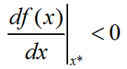 so the lower and upper fixed points are stable (the magenta and blue), and the intermediate fixed point is unstable (cyan). Since the initial conditions are $V_{out}(0)=0$ and $I(0)=0$, the fixed point is the lowest stable value as the input voltage increases from zero.

Analytically solving for the fixed point, we use the equation

$$\frac{df^{2}(x_{1})}{d{x_{1}}^{2}}=\frac{1}{2}(-17.76+207.58x_{1}-688.86{x_{1}}^{2}+905.24{x_{1}}^{3}-418.6{x_{1}}^{4}=0$$

Solving for the solution, we get that

$${x_{1}}^{*}=0.1381, 0.66014$$

To find the input voltage, we use the state equation

$$L\frac{dI}{dt}=V_{in}-IR-V_{out}$$

We find that

$$V_{in}=0.16380, 0.7626$$

The bifurcation plot below shows datatips at the numerical bifurcations, and another at the analytical bifurcation.

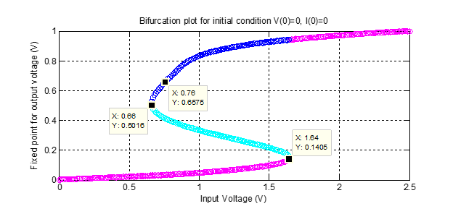

We note that the first bifurcation between the magenta and cyan matches the analytical solution, but the second (between the cyan and the blue) does not match. The analytical bifurcation point is found above the numerical solution.

When $V_{in}>1.64$, there is only one real fixed point. The output voltage jumps to this upper stable fixed point at the bifurcation value of 1.65 V. After this bifurcation point, the output voltage’s rise time starts to decrease. The following plot shows this jump at the bifurcation point.

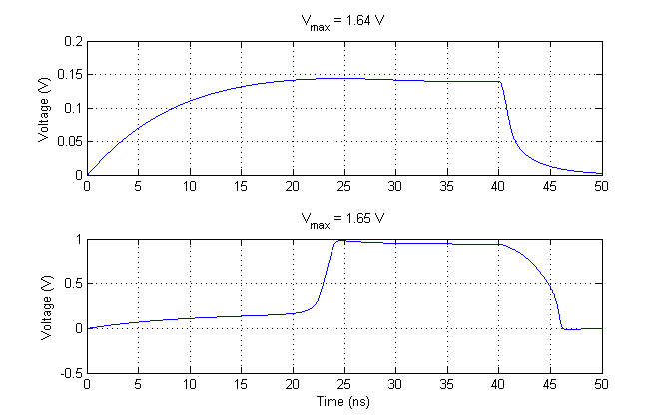

The following are sample plots of the output voltage vs. time. The top plot is before the bifurcation point and the bottom plot is after the bifurcation point.

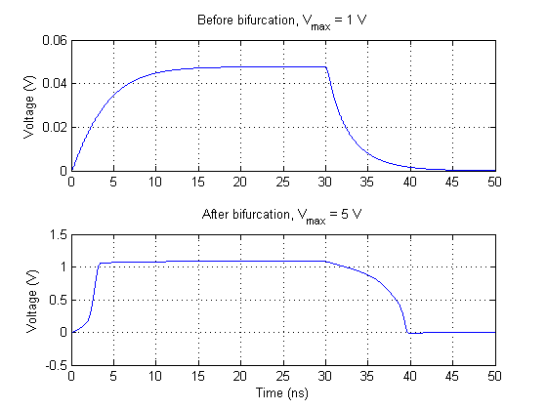

Note that the rise time for the first plot is about 10 ns, and rises gradually to the peak voltage expected. The second plot is after the bifurcation, and shows that the voltage shoots up close to the peak. It can also be seen that the rise time has significantly decreased from that of the graph showing $V_{max}=$ 1.65 V.